**Name >>> Muhammad Huzaifa**

**Roll No >>> 04**

**Part 1**

**Task 1**: Install VS code onto your system and install relevant html extensions for better coding  environment

**Solution:**

Already SetUp.

**Task 2**: Create a HTML file with proper formatting having name “Name_RollNumber”

**Solution:**



**Task 3**: Insert heading tags into your html file

**Solution:**

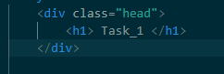

**Task 4**: Insert image into your html file

**Solution:**



**Task 5**: Set your page title to “Name_RollNumber”

**Solution:**



**Part 1 Front End:**

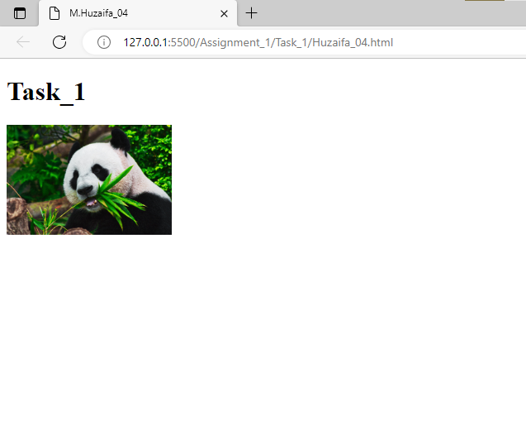

Part 2

**Task 3:** Create a file named as “index.html” in it

**Solution:**



**Task 5:** Assign a title to your html file as “Name_RollNumber”

**Solution:**



**Task 6:** Write your biodata using all text related html tags

1. e h1,h2,p,pre etc.

**Task 7:** Render an image with class based styling implementing background color with transparency of 50%.

**Solution:**

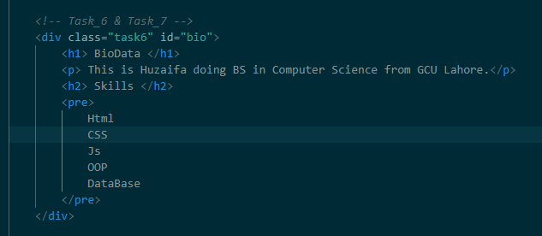

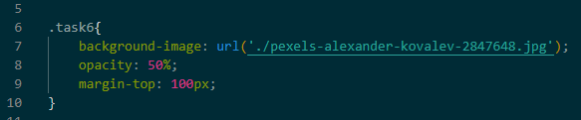

**Task 8:** Implement divs and spans and also elaborate the difference in a preformatted text tag with its size increased to 50 pixels.

**Solution:**

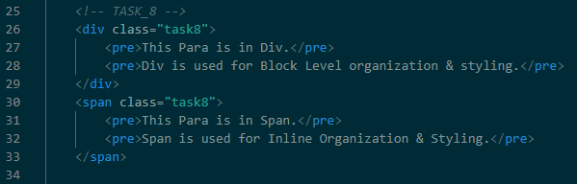

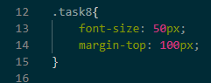

**Task 9:** Implement class based styling on your div having an image and two heading tags

**Solution:**

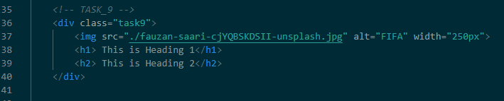

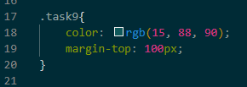

**Task 10:** Implement a span and perform margins and paddings and width separately to it and explain the results in the same row but three different columns.

**Solution:**

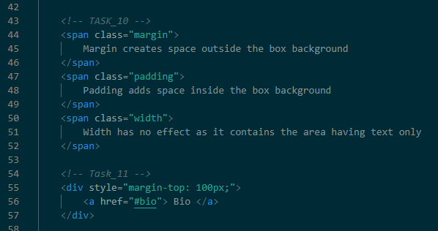

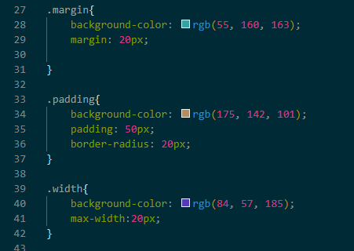

**Task 11:** Move to a specific section of a page using html

**Solution:**

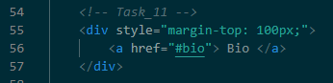

**Task 12:** Route to the other page using html

**Solution:**

**Task 13:** Move to a specific section of the other page using html

**Task 14:** Move to a specific section of the other page using html

**Solution:**

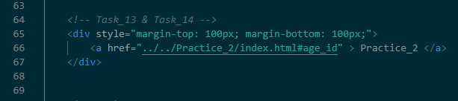

**Task 15:** Style your name in such a way that it looks white with background #569874 and inner space on the left

*Note: use inline styling

**Solution:**

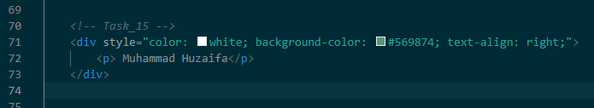

**Task 16:** Style your name in such a way that it looks white with background #569874 with opacity 0.8 and inner space on the left

*Note: use class based styles

**Solution:**

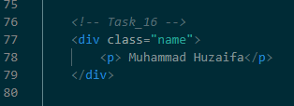

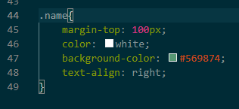

**Part 2 Front End:**

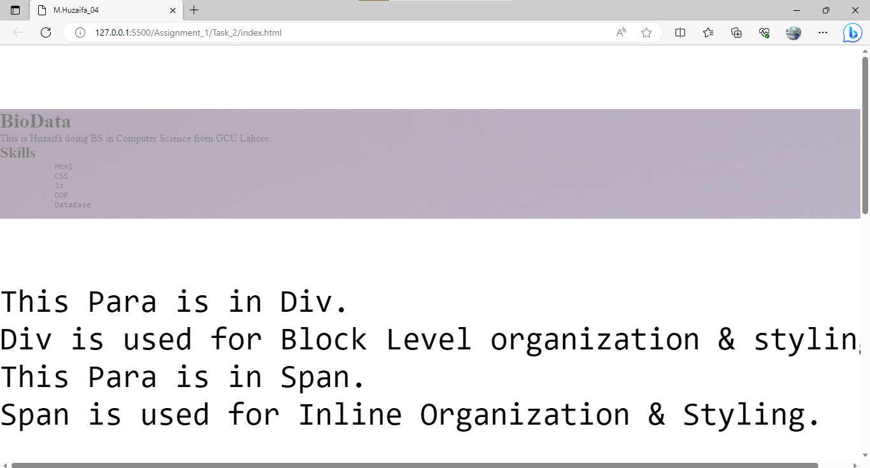

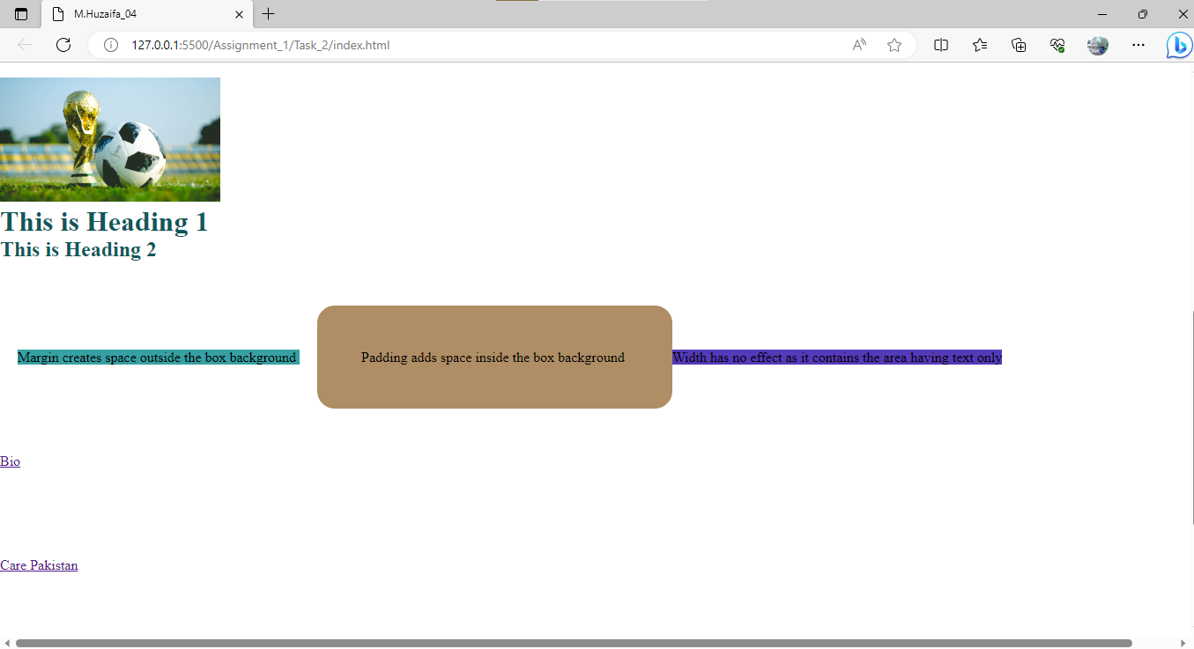

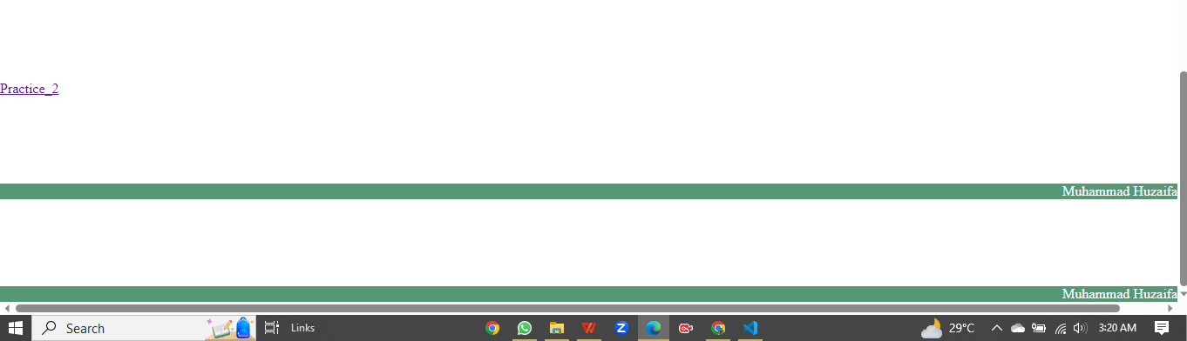

**Part 3**

**Task 1:**

**Create a table like this using html**

|  |  |  |  |  |  |  |  |  |  |  |
| --- | --- | --- | --- | --- | --- | --- | --- | --- | --- | --- |
| **Time** | **1** | **2** | **3** | **4** | **5** | **6** | **7** | **8** | **9** | **10** |
| **Distance** | **5** | **10** | **15** | **20** | **25** | **30** | **35** | **40** | **45** | **50** |

**Solution:**

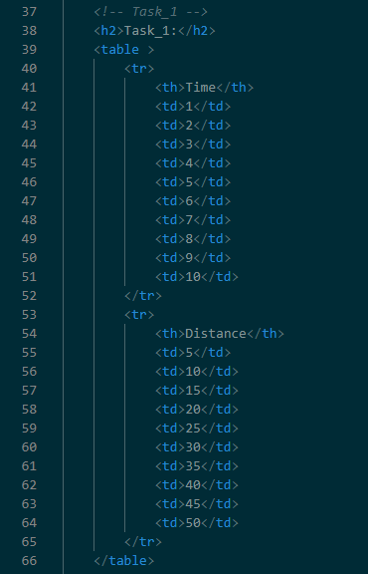

**Task 2:**Create an ordered list containing center aligned image and title (at least 5 points)

**Solution:**

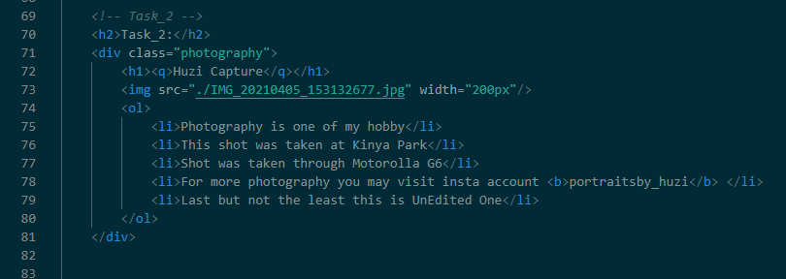

**Task 3**: Create a description list and enlist data of your 5 hobbies.

**Solution:**

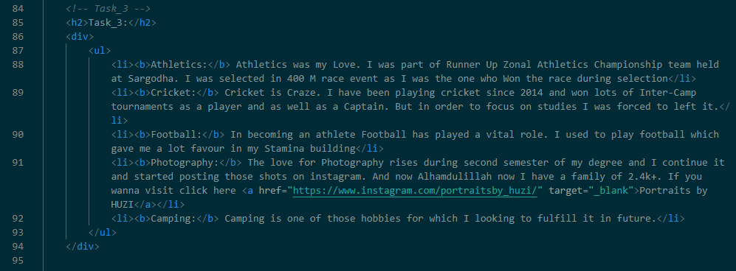

**Task 4:**Create an input field of type number allowing user to enter only numbers in the range of 50 to 100.

**Solution:**

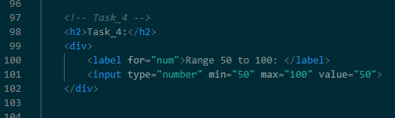

**Task 5:**Create a table like the one shown below using html

|  |  |
| --- | --- |
| **Time** | **Distance** |
| 1 | 5 |
| 2 | 15 |

**Solution:**

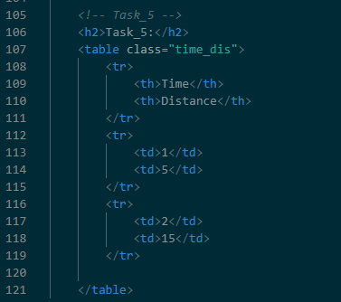

**Part 3 Front End:**

